Akhil Montrose

University of Trinidad and Tobago  Student ID: 81788

**Coffee Hub**

# Table of Contents

Table of Contents 1

Declaration 2

List of Acronyms 3

Introduction 4

Problem: 4

Solution: 4

Thesis 4

Main Points of this Chapter 5

Background & Literature Review 6

Development 6

Previous System 6

Existing Systems 6

Why This Choice was Taken 9

Main Points of this Chapter 9

Methodology 11

Approach to solving the problem 11

Solution 11

Requirements Analysis 11

Database 12

API 13

Input of data via forms 14

Sub-Components 15

Software Method 20

Main Points of this Chapter 21

Status Report 22

Main Points 22

Project Development Timeline 23

Anticipated Risks 25

Supervisor 26

Summary 30

Appendix 31

Project Proposal 31

Bibliography 33

# Declaration

I AKHIL MONTROSE student ID: 81788 Hereby Certify that I have not received any assistance in the creation of this document. This is my own original work.

_______________________ Date: _____________________

Signature

# List of Acronyms

|  |  |
| --- | --- |
| **Acronym** | **Meaning** |
| UI | User Interface |
| API | Application Programming Interface |
| UML | Unified Modeling Language |
| HTML | HyperText Markup Language |
| CSS | Cascading Style Sheets |
| SQL | Structured Query Language |
| PHP | Personal Home Page (previously), PHP: Hypertext Preprocessor (currently |

# Introduction

## Problem:

During this time of economic stability and a global pandemic, business have been forced to close down due to health concerns. Due to that, business haven’t been able to run as smoothly and effectively as they usually would. This is the case for all non-essential businesses such as restaurants, bars, cinemas to name a few. Today we will be discussing one particular coffee establishment called Coffee Hub..

Like all business affected by the pandemic, Coffee Hub was not able to provide meals for customers so this project’s aim is to create a solution for this problem.

## Solution:

To solve this problem, the goal is to design an online web app that will allow customers to browse the business menu online and be able to make orders and have it delivered to them at their location. Customers will order a meal, an employee of Coffee Hub will view the order, have it ready and have a driver deliver the coffee at their location.

## Thesis

The topic of this project is create a web application. The idea of this paper is to create a web application for a business which allows them to function essentially the say way they would prior to the pandemic occurring.

The main reasons that support this topic are:

* Create an online system that will allow the business to keep record of all their business transactions.
* Allow customers to be able to make orders for their coffee without physically be present at the establishment (due to the global pandemic).
* Allow the business to function at an otherwise full capacity without having gatherings at the establishment.

One main opposing viewpoint of this idea:

* There may be individuals who may not be able to access the website due to computer literacy, lack of internet access or lack of a device to access the website in general.

## Main Points of this Chapter

In this chapter we discussed the problem that the company, Coffee Hub faced as well as the proposed solution to that problem. In the following chapter, we will be discussing the background and the literature review of the project.

# Background & Literature Review

## Development

This project will be based on the development of a web application. [A web application](https://www.indeed.com/career-advice/career-development/what-is-web-application) is computer program that uses a web browser to perform a particular function. It is also called a web app. Web apps are present on many websites. A simple example is a contact form on a website. It is a client-server program. The client side is what the user interacts with while the server side is what does the processing the of the information that the user sent. An example of this is when you try to log in to an account. The client will interact with the forms and after they entered their information, it will be sent to the server for it to be processed. This project will be incorporating this same technology.

## Previous System

Prior to the pandemic, the company would utilize a file based system. They would record or transactions that would take place with customers. While the company managed by using this system, there are drawbacks.

* Important documents would be misplaced.
* Because it’s file based, paper clutter occurs.
* Files are destroyed.
* There is a limit when sharing data.
* Security problems occur when files are misplaced/destroyed.
* Data redundancy. There are multiple copies of the same files.

## Existing Systems

In Trinidad and Tobago, we have two popular coffee shows, which are Rituals and Starbucks. They both have an online web application that people can access but one only displays details about the coffee that they have on sale at one of their establishments as well as you cannot make an account or order on the menu (Starbucks).

Rituals on the other hand has a web app which allows users to either create an account or just make an order as a guest. They can also browse the menu as well as have their coffee delivered to the or ready for pickup. Below we will be doing a comparison of Rituals and what we intend to build for the web application of Coffee Hub.

|  |  |  |  |
| --- | --- | --- | --- |
|  | **Rituals** | **Starbucks** | **Coffee Hub** |
| **Web Application** | Yes | Yes | Yes |
| **Membership** | Yes but not necessary | No | Yes |
| **Browse online menu** | Yes | Yes | Yes |
| **Order items online** | Yes | Specific locations. | Yes |
| **Customers can pick-up** | Yes | Need to make order at a specific location | Yes |
| **Android/IOS app from their respective Appstore** | Yes | No | No |
| **Offers Delivery** | Yes | Only Drive-thru | Yes |

*Image showing UI for Rituals Coffee House* [*Website*](https://ritualscoffeehouse.com/order/)*.*

The image above shows the order page for rituals coffee. They have an option for members as well as if they want to make an order for pickup/delivery.

*Image 2 showing the locations of all the rituals coffee establishments in Trinidad*

*Image showing UI for Starbucks* [*Website*](https://www.starbucks.tt/)*.*

*Image showing the* [*map*](https://www.starbucks.com/store-locator?map=10.532657,-61.409979,9z) *of all the Starbucks Location in Trinidad  
(This page is outside of the StarbucksTT page)*

As you can see, there are only two major coffee establishments in the country where both of them customers can make an order but Starbucks only offer pickups while rituals coffee do both pickup and delivery. This system that we are building for coffee hub will be an online web based app that will give the edge to the 2 competing businesses.

## Why This Choice was Taken

Building a web app will have its benefits which include:

* It will be cost effective in the long run.
* Easily accessible for the employees.
* Employees will be able to keep track of their daily task.
* It offers a greater reach for customers.
* 24/7 accessibility.
* Improved productivity.
* It improves customer engagement.
* It also strengthens the Brand Image.

## Main Points of this Chapter

In this chapter we discussed the problems that the establishment faced, outlining the previous system that they utilized and its shortcomings. We also outlined the other establishments that sells coffee in Trinidad & Tobago and compared them. Finally, we outlined the benefits of building a web application for coffee hub.

In the next chapter, we will be discussing the methods that were taken to build the web application.

# Methodology

## Approach to solving the problem

In this chapter, we will be outlining:

* What was conducted at the business to determine the best possible solution for the problem.
* How we’re going to transition from using a paper based system to a database.
* The API/UI that will be used (How it will be divided between a view/actual customer/employee)
* How input is taken into the system via the UI.

## Solution

A survey was done at Coffee Hub and it was almost unanimous that they would love to have a better way of storing their information as well as being able to access it the data whenever needed. When we asked the customers what their most common daily tasks are, they included:

* Taking orders.
* Keeping a record of all the coffee they have available for a particular day.
* Store information about purchases made.

## Requirements Analysis

Similarly we did a survey to customers of the business and they stated that because of the pandemic, they were restricted to go as they please into the establishment. We asked what it is that can be done so that they can still have their coffee and they said:

* Create a system that they can access online.
* Must be able to view all of the coffee that available for them to choose from.
* Make an order for that they want.
* Have it delivered to them.

Because of the feedback we’ve received, we found out what are the main entities that they company deal with and they are:

* Customers
* Employees
* Orders
* Menu

In the next section we will be discussing that these 4 points mean and how a system will be built around it.

### Database

We have discovered that they 4 main items that the customer/employee interact with are the Customer, employee, order, and menu. Both customers and employees wants to be able to view things on the menu as well as make orders. Below is a UML class diagram which illustrates the relationship between these 4 entities.

For this project we will be utilizing a Centralized Database. A Centralized Database Management System (Network DBMS) is a collection of information at a single location accessible from numerous points. The advantages of using this database architecture includes:

* Ability to access all the information all at one location.
* It is easier to physically secure
* Higher levels of security can be obtained.
* There are fewer breakdowns present within the system.
* It can help businesses to stay close to a focused vision.
* Easier to make backups.

The architecture that we are going to use to store the information is SQL. All the information will be stored on a server (backups included.).

### API

The goal of building the API is to investigate what it is the users would like to perform. At coffee hub, the main focus centres around coffee (Viewing/creating orders or new things on the menu/Editing/Deleting etc). These are the common actions that both customers and employees perform on a daily basis.

The Programming language that is going to be used by the customer/employee to view/interact with the system is HTML/CSS.

[*Hypertext Markup Language (HTML)*](https://www.hostinger.com/tutorials/what-is-html) *is a computer language that makes up most web pages and online applications. A hypertext is a text that is used to reference other pieces of text, while a markup language is a series of markings that tells web servers the style and structure of a document.*

*HTML is not considered a programming language as it can’t create dynamic functionality. Instead, with HTML, web users can create and structure sections, paragraphs, and links using elements, tags, and attributes.*

There are a number of things that HTML can do which include:

* Web Development
* Internet Navigation
* Web Documentation

For this project we will be focusing on Web Development.

[*CSS*](https://blog.devmountain.com/what-is-css-and-why-use-it/) *stands for cascading style sheets. In short, CSS is a design language that makes a website look more appealing than just plain or uninspiring pieces of text. Whereas HTML largely determines textual content, CSS determines visual structure, layout, and aesthetics. HTML is a markup language, and CSS is a style sheet language. Think “look and feel” when you think CSS.*

The aim of creating a web app using HTML/CSS is to simulate what the customer/employee would actually do in the real world. From the user’s perspective the transition should be seamless.

### Input of data via forms

For the project, the web app will be utilizing form to input data. Information that will be taken into through the forms and the database include:

* Registration for new customer/employees.
* Login information for customer/employee.
* Creating forms for items on the menu.
* Editing information on menu and employee forms
* Creating forms for orders.

The way that the forms will be able to capture the data and sending it to the database is through the use of the programming language [PHP](https://www.php.net/manual/en/intro-whatis.php). The backend will be utilizing PHP to ensure that information is not only inputted but retrieved and edited.

*Information is inputted/requested from the client and then that request is sent to be server either to be stored in a database or to be retrieved and displayed back to the client side.*

## Sub-Components

**Forms**

The forms in this website will be used to input data for:

* User information when signing up (customer/employee).
* When logging in.
* When the admin is creating new objects to be displayed on the website.
* Validation will be done using html validation as well as JavaScript.
* PHP will be used to process the data entered in the forms to the database.

**Example of how a form would look like:**

**User Interface (UI)**

The user interface will be what they users of the website will be viewing/navigating through.

The UI will function as a link for the other sub-components.

* The UI will link the pages so that will lead to the forms e.g.: sign-up and login.
* Database information will be fetched and displayed using the UI.

**Example of how the Home UI will look:**

**Menu UI:**

**Database**

The database that will be utilized for this application is SQL.

* This database will be storing information on:
  + User information (customer/employee)
  + Items served on the menu.
  + Orders placed by customers.

## Software Method

The software method that this project will be utilizing is the Agile Model.

*Image showing the Agile Model and the required steps*

The Agile model in software development refers to a software development approach based on a combination of iterative and incremental processes with focus on adaptability and customer satisfaction. This model has 7 iterative phases:

1. Planning
2. Design
3. Develop
4. Test
5. Deploy
6. Review
7. Launch (after each iteration).

Benefits of using this method include:

* Better management control over the entire project.
* All of the iterations of this model is very transparent.
* Predictable results in terms of time, cost and deliveries.

## Main Points of this Chapter

In this chapter we discussed the approach we used to solve the problem as well as the project major components (database, API, forms etc) and how it will be built as well as how we acquired information from customer/employees of the company. Finally we discussed the software method used and the benefits of using that method (Agile methodology).

In the next chapter we will be discussing the status report of this project.

# Status Report

## Main Points

In this section, the topics that will be covered include:

* Project Development Timeline
* Anticipated Risks
* Supervisor
* Summary

## Project Development Timeline

Below is a Gantt Chart that displays phase 1 and phase two of the final project.

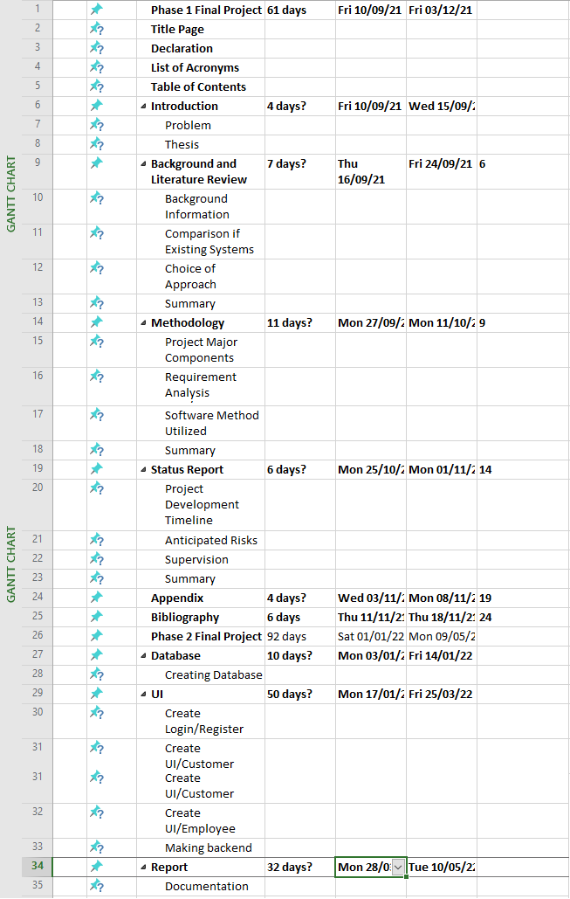

*Please note that this document only contains phase 1 of the final project. This Gantt Chart serves as a predictor of how long it’ll take to complete the project.*

The project is broken into two parts being Phase 1 and Phase 2.

* Phase 1: this is the documentation of the project (this document).
* Phase 2: this is the implementation of the project (Building the web application).

The entire project is expected to run from September 2021 to May 2022.

* Phase 1: September 2021 – December 2021.
* Phase 2: January 2022 – May 2022.

## Anticipated Risks

Some anticipated risks that have a chance of occurring include:

1. Time: May not have enough time to complete certain functionalities of the project.
2. Server issue: Server issues may or may not occur while using the application.
3. Budget: If enough money was not given to fund the project, certain functionalities may or may not be completed.

## Supervisor

The name of the supervisor that I choose to supervise my project is Dr. Ken Sooknanan.

We had scheduled meetings throughout the semester and it was documented.

**Meeting #1:**

Date: September 9th, 2021

Time: 5:00 pm

**Activities to be Discussed:**

* What project idea I choose to do
* Project proposal form.

**Discussion:**

* I highlighted that I wanted to do a web application for an online food delivery. He told me that was a good idea and gave me a green light to start.
* Dr. Sooknanan outlined that is needed in the project proposal.

**Signature of Supervisor:**

**____________________________**

**Meeting #2:**

Date: September 16th, 2021

Time: 5:00 pm

**Activities to be Discussed:**

* Project idea
* Project proposal form.

**Discussion:**

* Discussed what we did for our proposal form thus far.
* Dr Sooknanan highlighted that there was someone who has a similar idea as mine and requested that I changed it to something what is not too far from the original idea but different from the clashing ideas.

**Signature of Supervisor:**

**____________________________**

**Meeting #3:**

Date: September 25th, 2021.

Time: 5:00 pm

**Activities to be Discussed:**

* Project idea
* About databases and UI

**Discussion:**

* I notified the supervisor what project idea I wanted to do (coffee).
* I asked Dr Sooknanan if I had to create any database or UI for the project and he told me that is to be done in phase 2 but I needed to discuss what database and framework I will choose to do in phase 1.
* I asked Dr. Sooknanan about the sub-components and how it should be done. He then explained what must be done in that section of the document.

**Signature of Supervisor:**

**____________________________**

**Meeting #4:**

Date: November 12th, 2021.

Time: 5:30 pm

**Activities to be Discussed:**

* Presentation for Phase 1
* Gantt Chart for Project

**Discussion:**

* I asked my supervisor when it is that we have to present our stuff for Phase 1. He replied and told me that it will take place during January.
* I asked about what is to be included in the Gantt chart. He told me that I have to make an estimate of when Phase 1 and Phase 2 are to be completed, listing the tasks that need to be done to completed.

**Signature of Supervisor:**

**____________________________**

**Experience with Supervisor:**

Dr Sooknanan has been really helpful anytime I had any questions about my project. He is very approachable and he takes his time to explain what needs to be done or to give advice on what to improve for my project.

Every Thursday we have a class with him concerning Phase 1 documentation. Every class I may not have something to say but he’s always available if I have any questions.

**In the future:**

When I start Phase 2 any queries I have, I will be seeing Dr Sooknanan since he has been so helpful while doing Phase 1. I look forward to working with him next semester.

## Summary

In this section we covered:

* Timeline for phase 1 project.
* Anticipated risks involved in this project.
* Supervisor and meetings conducted.
* Future endeavours.

# Appendix

## Project Proposal

|  |  |  |  |
| --- | --- | --- | --- |
| Description: UTT-LogoProject Proposal Form for B.A.Sc. in Computer Engineering | | | |
| **Section A – Personnel Information** | | | |
| Student Name | Akhil Montrose | Supervisor(s) Name | Ken Sooknanan |
| Student ID | 81788 | Supervisor Email: | Ken.sooknanan@utt.edu.tt |
| Student Email Address | [akhilmontrose62@gmail.com](mailto:akhilmontrose62@gmail.com) | Supervisor Phone # | 1(868)-793-8671 |
| Student Phone # | 275-5992 |  |  |
| **Section B – Project Information** | | | |
| Project Title: Coffee Hub | | | |
| Project Type (Development or Research): Development | | | |
| Project Overview (describe the project in 1-2 lines, and list all its deliverables): The aim of this project is to create a web-based application for an online coffee delivery service named CoffeeHub.   1. Employees using the web app will be able to create an account/login. 2. Customer will be able to create an account/login into the system. 3. Their information (username, address, password etc) will be stored on a database through the use of forms and can also be retrieved as well. 4. This also is the case for the items on the menu. Items on the menu will be stored in the database and can be retrieved at any point. 5. Employees will be able to Create/Update/Delete/View the menu while 6. The customer will be able to View as well as Order from the menu. | | | |
| **Section C – Administrative Information** | | | |
| Course Code | PROJ3019 | Course Title | Final Project Design -ICT |
| Semester (I or II) | I | Project Time Frame (est.) | September 2021 – May 2022 |
| Student Signature & Date: | |  | |
| Supervisor Signature & Date: | |  | |
| Project Coordinator Signature & Date: | |  | |

# Bibliography

*What Is a Web Application? How It Works, Benefits and Examples*

[*https://www.indeed.com/career-advice/career-development/what-is-web-application*](https://www.indeed.com/career-advice/career-development/what-is-web-application)

*Nov 05, 2021 (Susan C.) What Is HTML? Hypertext Markup Language Basics Explained*

[*https://www.hostinger.com/tutorials/what-is-html*](https://www.hostinger.com/tutorials/what-is-html)

*What Is CSS and Why Should You Use It?*

[*https://blog.devmountain.com/what-is-css-and-why-use-it/*](https://blog.devmountain.com/what-is-css-and-why-use-it/)

*What is PHP?*

[*https://www.php.net/manual/en/intro-whatis.php*](https://www.php.net/manual/en/intro-whatis.php)